Lecture Notes in Earth System Sciences: Authors’ Instructions for the Preparation of Contributions to IAMG Madrid 2013
Carolina Guardiola-Albert¹, Eulogio Pardo-Igúzquiza¹, Javier Heredia¹ and Luis Moreno Merino¹
1 Spanish Geological Survey, C/ Ríos Rosas, 23, 28003 Madrid, Spain
c.guardiola@igme.es, e.pardo@igme.es, j.heredia@igme.es, l.moreno@igme.es
Abstract. The abstract should summarize the contents of the paper and should be 10 to 15 lines long. It should be set in 10-point font size and the width text should be 10 cm or 3.94 inches.
Keywords: We would like to encourage you to list your keywords in this section (maximum5 keywords).
1 Introduction
This instruction file for Word users (there is a separate instruction file for LaTeX users) may be used as a template. Kindly send the final and checked Word and PDF files of your paper to the Conveners. You should make sure that the Word and the PDF files are identical and correct and that only one version of your paper is sent. It is not possible to update files at a later stage.
We would like to draw your attention to the fact that it is not possible to modify a paper in any way, once it has been published. Every detail, including the order of the names of the authors, should be checked before the paper is sent.
1.1 Checking the Word/PDF File
Kindly assure that the Convener is given the name and email address of the contact author for your paper.
The tight publication schedule of IAMG Madrid 2013 Proceedings does not allow Conveners to send reminders or search for alternative email addresses on the Internet.
2 Paper Preparation
The text should be justified to occupy the full line width, so that the right margin is not ragged, with words hyphenated as appropriate. Please fill pages so that the length of the text is 180 mm or 7.1 inches and the width is 12 cm or 4.75 inches. Use 10-point type for the name(s) of the author(s) and 9-point type for the address(es) and the abstract. For the main text, please use 10-point type and single-line spacing. We recommend the use of Times. Italic type may be used to emphasize words in running text. Bold type and underlining should be avoided.
2.1 Headings
Please use the decimal system of headings with no more than four levels. Headings should be capitalized (i.e., nouns, verbs, and all other words except articles, prepositions, and conjunctions should be set with an initial capital) and should, with the exception of the title, be aligned to the left. Words joined by a hyphen are subject to a special rule. If the first word can stand alone, the second word should be capitalized. The font sizes are given in Table 1. Here are some examples of headings: "Criteria to Disprove Context-Freeness of Collage Languages", "On Correcting the Intrusion of Tracing Non-deterministic Programs by Software", "A User-Friendly and Extendable Data Distribution System", "Multi-flip Networks: Parallelizing GenSAT", "Self-determinations of Man".
Table 1. Font sizes of headings. Table captions should always be positioned above the tables.
Heading level | Example | Font size and style
Title (centered) | Lecture Notes … | 16 point, bold
1st-level heading | 1 Introduction | 12 point, bold
2nd-level heading | 2.1 Printing Area | 12 point, bold, italic
3rd-level heading | 3.1.1 Headings. Text follows | 10 point, bold
4th-level heading | 4.2.1.1 Remark. Text follows | 10 point, italic
2.2 Figures
Please check that the lines in line drawings are not interrupted and have a constant width. Grids and details within the figures must be clearly legible and may not be written one on top of the other. Line drawings should have a resolution of at least 800 dpi (preferably 1200 dpi). The lettering in figures should have a height of 2mm (10-point type). Figures should be numbered and should have a caption which should always be positioned under the figures, in contrast to the caption belonging to a table, which should always appear above the table. Please center the captions between the margins and set them in 9-point type (Fig. 1 shows an example). You should leave a blank line between text and figures. The distance between figure and caption should be about 6mm.
2.2.1 Remark
Colored pictures are free of charge.

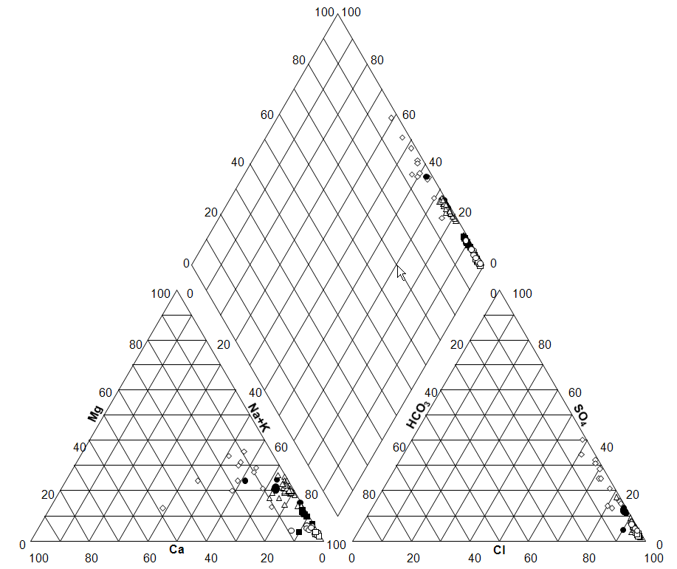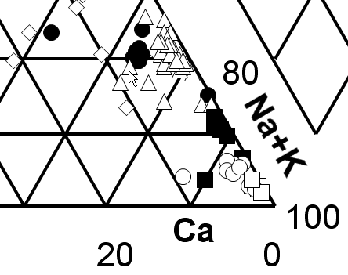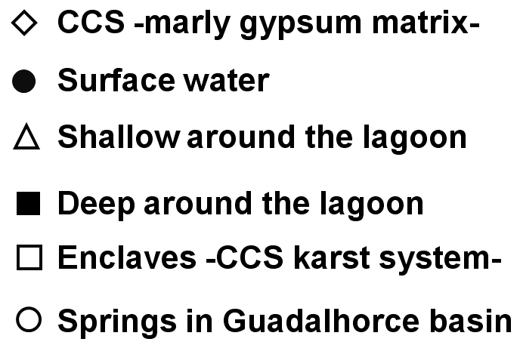
Fig. 1. Groundwater brine (TDS>50g/l) Piper diagram Elements of the figure described in the caption should be set in italics, in parentheses, as shown in this sample caption.
2.3 Formulas
Displayed equations or formulas are centered. Displayed expressions should be numbered for reference. The numbers should be consecutive within each section or within the contribution, with numbers enclosed in parentheses and set on the right margin.
x + y = z . | (1)
Equations should be punctuated in the same way as ordinary text but with a small space before the end punctuation mark.
2.5 Citations
For citations in the text please use square brackets and consecutive numbers: [1], [2], [3], etc.
2.6 Page Numbering and Running Heads
There is no need to include page numbers. If your paper title is too long to serve as a running head, it will be shortened. Your suggestion as to how to shorten it would be most welcome.

Acknowledgments. The heading should be treated as a 3rd level heading and should not be assigned a number.
3 The References Section
You should check your references thoroughly. We only accept references written using the latin alphabet. If the title of the book you are referring to is in Russian or Chinese, then please (e.g.) in Russian or in Chinese at the end of the transcript or translation of the title. The following section shows a sample reference list with entries for journal articles [1], a chapter [2], a book [3], proceedings without editors [4] and [5], as well as a URL [6].
References
1. Smith, T.F., Waterman, M.S.: Identification of Common Molecular Subsequences. J. Mol. Biol. 147, 195--197 (1981)
2. May, P., Ehrlich, H.C., Steinke, T.: ZIB Structure Prediction Pipeline: Composing a Complex Biological Workflow through Web Services. In: Nagel, W.E., Walter, W.V., Lehner, W. (eds.) Euro-Par 2006. LNCS, vol. 4128, pp. 1148--1158. Springer, Heidelberg (2006)
3. Foster, I., Kesselman, C.: The Grid: Blueprint for a New Computing Infrastructure. Morgan Kaufmann, San Francisco (1999)
4. Czajkowski, K., Fitzgerald, S., Foster, I., Kesselman, C.: Grid Information Services for Distributed Resource Sharing. In: 10th IEEE International Symposium on High Performance Distributed Computing, pp. 181--184. IEEE Press, New York (2001)
5. Foster, I., Kesselman, C., Nick, J., Tuecke, S.: The Physiology of the Grid: an Open Grid Services Architecture for Distributed Systems Integration. Technical report, Global Grid Forum (2002)
6. National Center for Biotechnology Information, http://www.ncbi.nlm.nih.gov

